Create a simple cloud web application for student counselling system using any Cloud Service Provider to demonstrate SaaS with the fields of student name, age, address, phone, subjects studied, Year of passing, percentage of marks, domain interest, etc.

Step 1:Create the form of student details

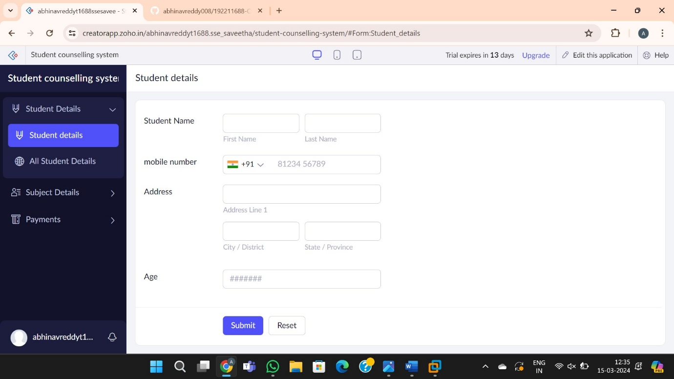

Step 2:Create the form of Subject details

Step3: Create a form of payments